Chimzim Ogbondah

SE 319

Homework 4

Design Analysis

For Creating the table design I used the basic table format to have the Headers print out as they are just static strings that don’t need to be updated. I then made a function called createTableBody() which uses the map and keys to create the actual body of the table. At first I tried to go through and manually input all the values inside the table function (while still using React) but I was getting a warning saying that I needed to use a <tbody> tag. I did some research on how to loop through arrays which led me to the map function. I use destruction to grab each individual component from the cars array. The key rowCount allows me to keep track of the which array position I am deconstructing. I simply then create a table row that contains data Cells where I put the data of each element into their respective position in the table. I then made a button that calls addOneToStock which is called if the button is clicked and also takes in the rowCount. My addOneToStock takes in this key. In order to increment the stock by one I first split the array into each “component” using the .slice() function. From there I take the rowCount of this function which aligns with the key from creating the table so it grabs the right component and from there I just use .stock to grab the stock variable and increment it by one. Finally setState is called so it updates the state of that component but I pass in the entire sliced array. (React only updates the components that have been changed).

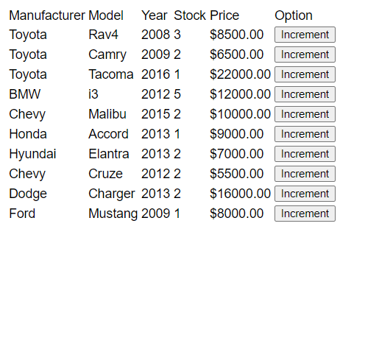

After clicking increment for each button:

